LABSHEET-9 Garimauppal
CU240251618
ROLL NO-22
SEC-B
import pandas as pd import numpy as np
import matplotlib.pyplot as plt import seaborn as sns
from google.colab import files
pd.set_option('display.max_columns', None) sns.set_style("whitegrid")
print("Libraries imported successfully!")

Libraries imported successfully!

- Select a real-world dataset such as the Global Superstore Sales Dataset, Netflix Dataset,World Happiness Report, or COVID-19 Dataset.
uploaded = files.upload()

Choose files netflix_titles.csv
netflix_titles.csv(text/csv) - 3399671 bytes, last modified: 21/09/2026 - 100% done
Saving netflix_titles.csv to netflix_titles (1).csv
df = pd.read_csv("netflix_titles.csv")
print("Dataset loaded successfully!") print("Shape:", df.shape)
df.head()

Dataset loaded successfully! Shape: (8807, 12)
show_id type title director
cast country date_added release_year rating duration listed_in description
0
s1 Movie
Dick Johnson Is
Dead
Kirsten Johnson
NaN United September
States 25, 2021
As her father
2020 PG-13 90 min Documentaries nears the
end of his
life, filmm...
1
s2 TV
Show
Blood & Water
NaN
Ama Qamata, Khosi Ngema,
Gail Mabalane, Thaban...
South September Africa 24, 2021
2021 TV-MA 2
Seasons
International TV Shows, TV Dramas, TV Mysteries
After crossing paths at a party, a Cape
Town t...
2
Sami Bouajila,
Tracy s3 TV Ganglands Julien Gotoas,
NaN
September
2021 TV-MA 1 Season
Crime TV Shows,
International
To protect his family from a
Next steps: Generate code with df New interactive sheet

- Analyze the dataset to identify the primary business problem or analytical objective.
print("""
BUSINESS PROBLEM / ANALYTICAL OBJECTIVE
The objective of this analysis is to understand the content available on Netflix and identify important patterns related to:
- Movies and TV Shows
- Content released over the years
- Popular genres/categories
- Countries producing Netflix content
- Content ratings
- Content duration
- Recent content trends
These insights can help understand Netflix's content strategy and

identify areas of growth and improvement. """)

BUSINESS PROBLEM / ANALYTICAL OBJECTIVE
The objective of this analysis is to understand the content available on Netflix and identify important patterns related to:
- Movies and TV Shows
- Content released over the years
- Popular genres/categories
- Countries producing Netflix content
- Content ratings
- Content duration
- Recent content trends
These insights can help understand Netflix's content strategy and identify areas of growth and improvement.
- Perform exploratory data analysis to discover significant trends, patterns, correlations,and anomalies.

Cell 4 — Basic dataset information
print("Number of rows:", df.shape[0])
print("Number of columns:", df.shape[1]) print("\nColumn Names:")
print(df.columns.tolist())
print("\nDataset Information:") df.info()

Cell 5 — Statistical summary

 | count | unique | top | freq | mean | std | min | 25% | 50% | 75% | max
show_id | 8807 | 8807 | s8807 | 1 | NaN | NaN | NaN | NaN | NaN | NaN | NaN
type | 8807 | 2 | Movie | 6131 | NaN | NaN | NaN | NaN | NaN | NaN | NaN
title | 8807 | 8807 | Zubaan | 1 | NaN | NaN | NaN | NaN | NaN | NaN | NaN
director | 6173 | 4528 | Rajiv Chilaka | 19 | NaN | NaN | NaN | NaN | NaN | NaN | NaN
cast | 7982 | 7692 | David Attenborough | 19 | NaN | NaN | NaN | NaN | NaN | NaN | NaN
country | 7976 | 748 | United States | 2818 | NaN | NaN | NaN | NaN | NaN | NaN | NaN
date_added | 8797 | 1767 | January 1, 2020 | 109 | NaN | NaN | NaN | NaN | NaN | NaN | NaN
release_year | 8807.0 | NaN | NaN | NaN | 2014.180198 | 8.819312 | 1925.0 | 2013.0 | 2017.0 | 2019.0 | 2021.0
rating | 8803 | 17 | TV-MA | 3207 | NaN | NaN | NaN | NaN | NaN | NaN | NaN
duration | 8804 | 220 | 1 Season | 1793 | NaN | NaN | NaN | NaN | NaN | NaN | NaN
listed_in | 8807 | 514 | Dramas, International Movies | 362 | NaN | NaN | NaN | NaN | NaN | NaN | NaN

4 | NaN | NaN | NaN | NaN | NaN | NaN | NaN

Cell 6 — Check missing values
df.describe(include='all').T
description 8807 8775
Paranormal activity at a lush,
abandoned prope...
missing_values = df.isnull().sum()
missing_percentage = (df.isnull().sum() / len(df)) * 100 missing_df = pd.DataFrame({
"Missing Values": missing_values, "Percentage": missing_percentage
})
missing_df = missing_df.sort_values( by="Percentage",
ascending=False
)
missing_df

 |  | Missing Values | Percentage
 | director | 2634 | 29.908028
 | country | 831 | 9.435676
 | cast | 825 | 9.367549
 | date_added | 10 | 0.113546
 | rating | 4 | 0.045418
 | duration | 3 | 0.034064
 | show_id | 0 | 0.000000
 | type | 0 | 0.000000
 | title | 0 | 0.000000
 | release_year | 0 | 0.000000
 | listed_in | 0 | 0.000000
 | description | 0 | 0.000000

Cell 7 — Check duplicate records
Next steps: Generate code with missing_df New interactive sheet
print("Number of duplicate rows:", df.duplicated().sum())

Number of duplicate rows: 0
df = df.drop_duplicates()
print("Shape after removing duplicates:", df.shape)

Shape after removing duplicates: (8807, 12)

- Develop a set of meaningful visualizations such as bar charts, line graphs, heatmaps,and dashboards to support the analysis.

Cell 8 — Handle missing values
text_columns = [ 'director', 'cast',
'country', 'rating',
'duration', 'listed_in', 'description'
]
for col in text_columns: if col in df.columns:
df[col] = df[col].fillna("Unknown") print("Missing text values handled.")

Missing text values handled.

Cell 9 — Convert date column
df['date_added'] = pd.to_datetime( df['date_added'],
errors='coerce'
)
print("Date column converted successfully.") df[['date_added']].head()

Date column converted successfully.
date_added
0 2021-09-25
1 2021-09-24
2 2021-09-24
3 2021-09-24
4 2021-09-24
Cell 10 — Create useful year columns

date_added | year_added | month_added
0 2021-09-25 | 2021.0 | 9.0
1 2021-09-24 | 2021.0 | 9.0
2 2021-09-24 | 2021.0 | 9.0
3 2021-09-24 | 2021.0 | 9.0
4 2021-09-24 | 2021.0 | 9.0

- Identify Key Performance Indicators (KPIs) and highlight important business metrics relevant to the selected dataset.
df['year_added'] = df['date_added'].dt.year
df['month_added'] = df['date_added'].dt.month
df[['date_added', 'year_added', 'month_added']].head()

Visualization 1 — Movies vs TV Shows Cell 11
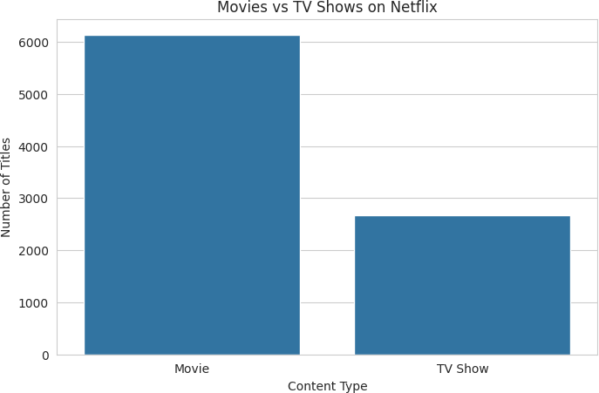
content_type = df['type'].value_counts() plt.figure(figsize=(8, 5))
sns.barplot(
x=content_type.index, y=content_type.values
)
plt.title("Movies vs TV Shows on Netflix") plt.xlabel("Content Type")
plt.ylabel("Number of Titles") plt.show()

Visualization 2 — Content Added Over the Years

Cell 12
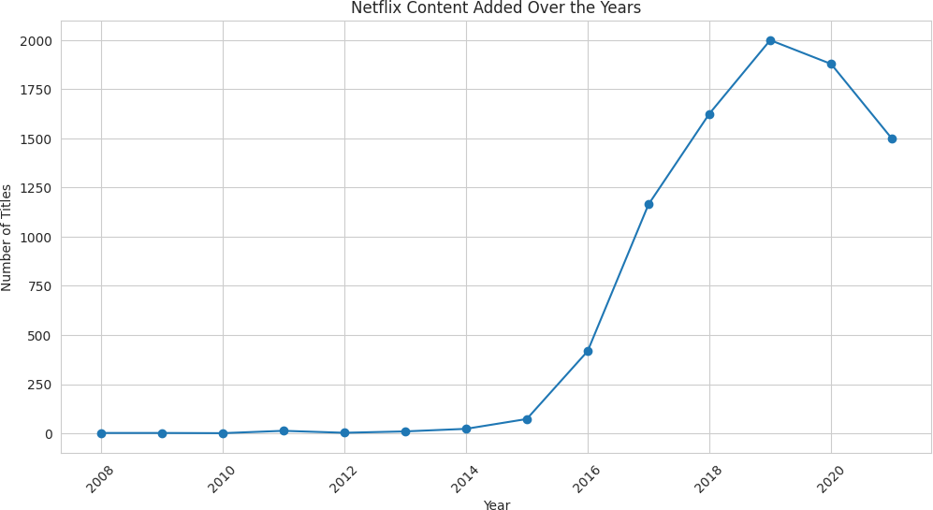
yearly_content = df['year_added'].value_counts().sort_index() plt.figure(figsize=(12, 6))
plt.plot(
yearly_content.index, yearly_content.values, marker='o'
)
plt.title("Netflix Content Added Over the Years") plt.xlabel("Year")
plt.ylabel("Number of Titles") plt.xticks(rotation=45)
plt.show()

Visualization 3 — Top Genres
The listed_in column contains multiple genres, so we need to separate them. Cell 13
genres = df['listed_in'].dropna().str.split(', ') genre_list = []
for genre in genres:
genre_list.extend(genre)
genre_counts = pd.Series(genre_list).value_counts() genre_counts.head(10)

 |  | count
 | International Movies | 2752
 | Dramas | 2427
 | Comedies | 1674
 | International TV Shows | 1351
 | Documentaries | 869
 | Action & Adventure | 859
 | TV Dramas | 763
 | Independent Movies | 756
 | Children & Family Movies | 641
 | Romantic Movies | 616

Cell 14 — Plot top 10 genres
dtype: int64
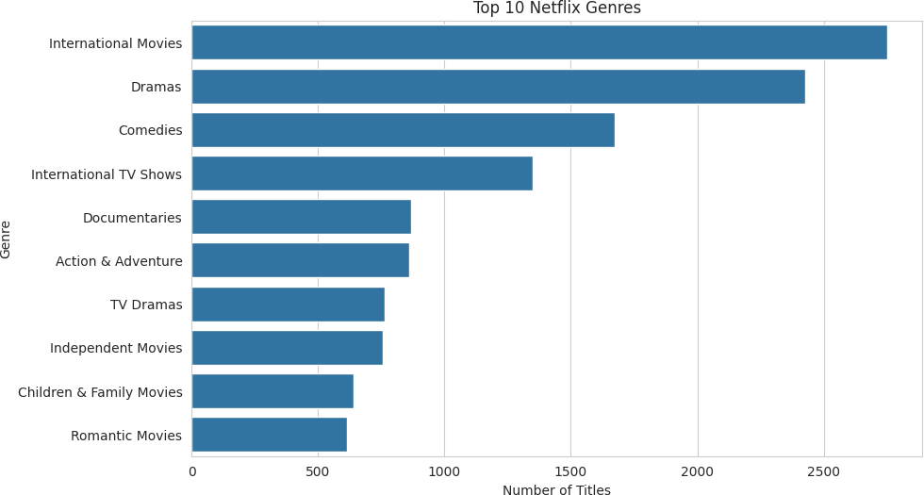
top_genres = genre_counts.head(10) plt.figure(figsize=(10, 6))
sns.barplot(
x=top_genres.values, y=top_genres.index
)
plt.title("Top 10 Netflix Genres") plt.xlabel("Number of Titles")
plt.ylabel("Genre") plt.show()

Visualization 4 — Content by Country Cell 15

 |  | count
 | United States | 3689
 | India | 1046
 | Unknown | 831
 | United Kingdom | 804
 | Canada | 445
 | France | 393
 | Japan | 318
 | Spain | 232
 | South Korea | 231
 | Germany | 226

Cell 16
countries = df['country'].dropna().str.split(', ')
country_list = []
for country in countries:
country_list.extend(country)
country_counts = pd.Series(country_list).value_counts() country_counts.head(10)
dtype: int64
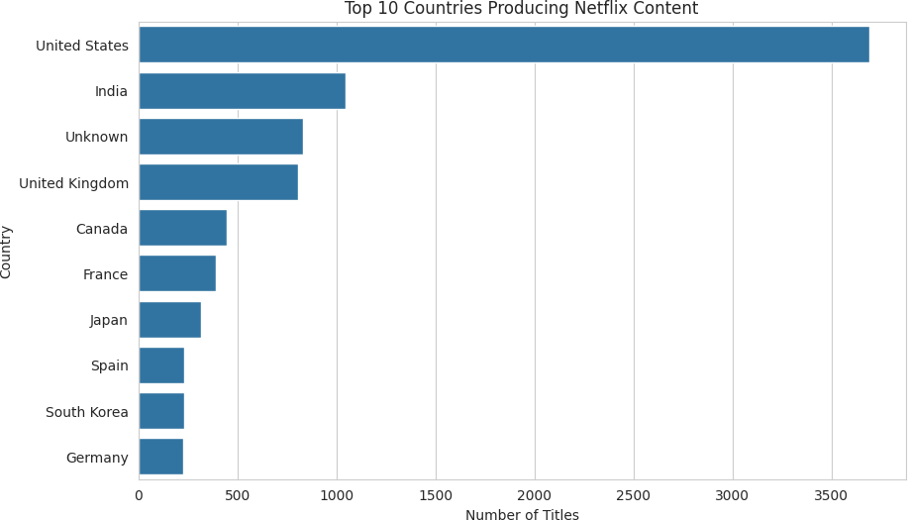
top_countries = country_counts.head(10) plt.figure(figsize=(10, 6))
sns.barplot(
x=top_countries.values, y=top_countries.index
)
plt.title("Top 10 Countries Producing Netflix Content") plt.xlabel("Number of Titles")
plt.ylabel("Country") plt.show()

Visualization 5 — Content Rating Distribution Cell 17

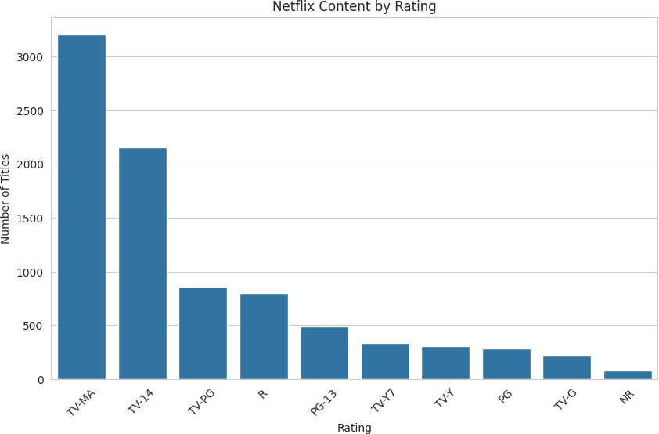
rating_counts = df['rating'].value_counts().head(10) plt.figure(figsize=(10, 6))
sns.barplot(
x=rating_counts.index, y=rating_counts.values
)
plt.title("Netflix Content by Rating") plt.xlabel("Rating")
plt.ylabel("Number of Titles") plt.xticks(rotation=45)
plt.show()
Visualization 6 — Movies vs TV Shows by Year Cell 18
year_type = pd.crosstab( df['year_added'],
df['type']
)
plt.figure(figsize=(12, 6)) year_type.plot(
kind='line', marker='o',
figsize=(12, 6)
)
plt.title("Movies vs TV Shows Added Over Time") plt.xlabel("Year")
plt.ylabel("Number of Titles") plt.grid(True)
plt.show()

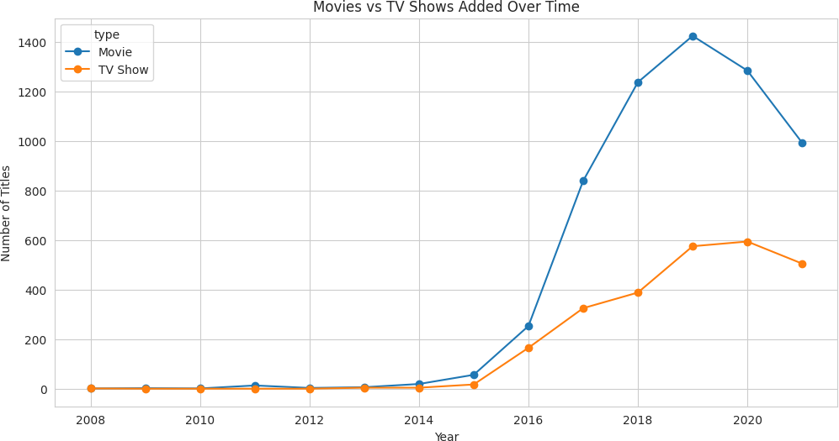
<Figure size 1200x600 with 0 Axes>
Visualization 7 — Heatmap
The heatmap helps identify relationships between content type and rating. Cell 19
rating_type = pd.crosstab( df['rating'],
df['type']
)
plt.figure(figsize=(10, 8)) sns.heatmap(
rating_type, annot=True, fmt='d',
cmap='Blues'
)
plt.title("Heatmap of Content Rating vs Content Type") plt.xlabel("Content Type")
plt.ylabel("Rating") plt.show()

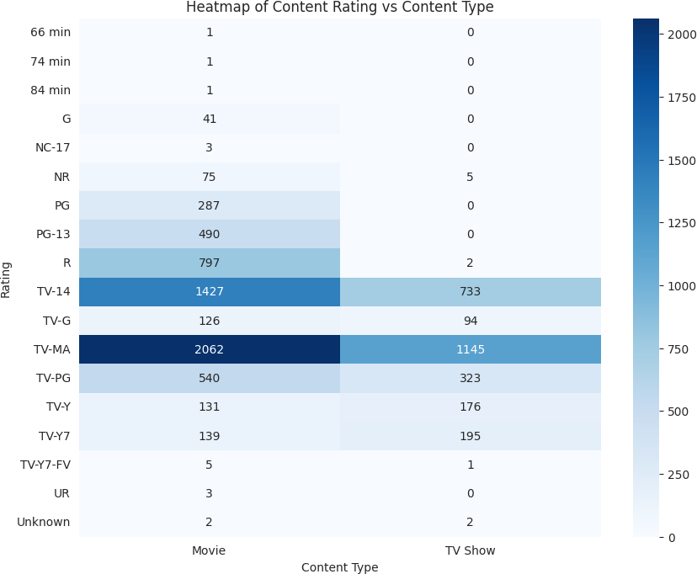
- Arrange the visualizations in a logical sequence to create a coherent data story that explains the problem, analysis, findings, and recommendations.
fig, axes = plt.subplots(2, 2, figsize=(16, 12)) content_type.plot(
kind='bar',
ax=axes[0, 0]
)
axes[0, 0].set_title("Movies vs TV Shows") axes[0, 0].set_xlabel("Content Type")
axes[0, 0].set_ylabel("Number of Titles") yearly_content.plot(
kind='line', marker='o',
ax=axes[0, 1]
)
axes[0, 1].set_title("Content Added Over Years") axes[0, 1].set_xlabel("Year")
axes[0, 1].set_ylabel("Number of Titles") top_genres.head(5).plot(
kind='bar',
ax=axes[1, 0]
)
axes[1, 0].set_title("Top 5 Genres") axes[1, 0].set_xlabel("Genre")
axes[1, 0].set_ylabel("Number of Titles") top_countries.head(5).plot(
kind='bar',
ax=axes[1, 1]
)
axes[1, 1].set_title("Top 5 Countries") axes[1, 1].set_xlabel("Country")
axes[1, 1].set_ylabel("Number of Titles") plt.tight_layout()
plt.show()

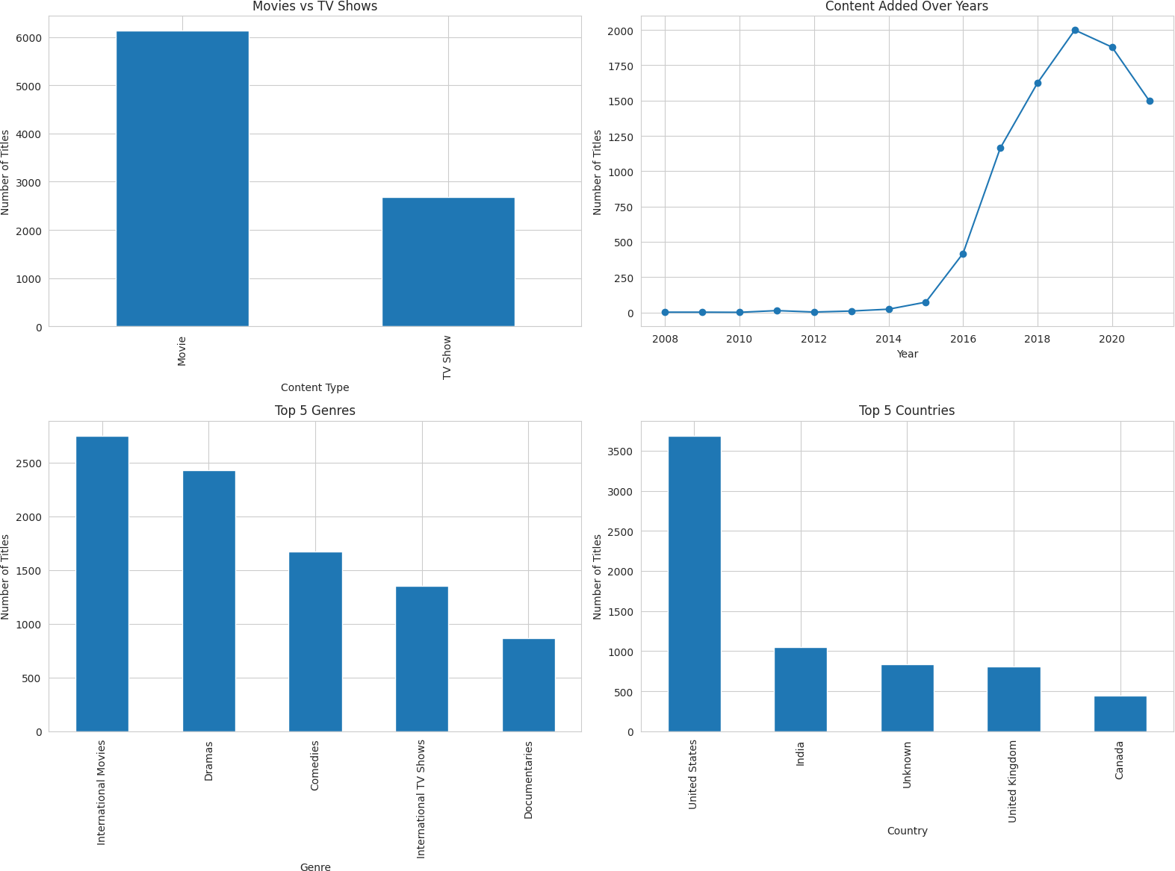
- Prepare actionable recommendations based on the analytical findings to support business decision-making.

Cell 22
print("========== BUSINESS INSIGHTS ==========\n")
print("1. Content Mix:") print(
f"Netflix contains {total_movies} Movies and " f"{total_tv_shows} TV Shows in the dataset."
)
print("\n2. Most Common Genres:") print(
"The most common genres are:"
)
print(top_genres.head(5))
print("\n3. Leading Content-Producing Countries:") print(
"The leading countries by number of titles are:"
)
print(top_countries.head(5))

International Movies | 2752
Dramas | 2427
Comedies | 1674
International TV Shows | 1351
Documentaries  Name: count, dtype: int64 | 869

United States | 3689
India | 1046
Unknown | 831
United Kingdom | 804
Canada | 445

- Present the complete data story using presentation slides, Tableau, Power BI, or a Jupyter Notebook.
print("\n4. Content Growth:")
print(
"The yearly content trend shows how Netflix's content " "library has changed over time."
)
print("\n5. Content Ratings:") print(
"The rating distribution shows which audience categories " "are most represented in the dataset."
)

========== BUSINESS INSIGHTS ==========

- Content Mix:
Netflix contains 6131 Movies and 2676 TV Shows in the dataset.

- Most Common Genres:
The most common genres are:
3. Leading Content-Producing Countries:
The leading countries by number of titles are:
Name: count, dtype: int64

- Content Growth:
The yearly content trend shows how Netflix's content library has changed over time.

- Content Ratings:
The rating distribution shows which audience categories are most represented in the dataset.

Cell 23
print("""
========== ACTIONABLE RECOMMENDATIONS ==========
- Content Strategy:
Netflix can monitor the distribution of Movies and TV Shows to maintain a balanced content portfolio.
- Genre Strategy:
Popular genres can be monitored to understand viewer interests and guide future content planning.
- Regional Strategy:
Countries with strong content representation can be analyzed for regional content opportunities.
- Audience Strategy:
Content ratings can be used to understand the target audience distribution and support appropriate content planning.
- Trend Monitoring:
Year-wise content trends can be continuously monitored to understand changes in content production and availability.
- Performance Monitoring:
KPIs and dashboards can be updated regularly so that analysts and managers can monitor changes in the content library.
""")
========== ACTIONABLE RECOMMENDATIONS ==========
- Content Strategy:
Netflix can monitor the distribution of Movies and TV Shows to maintain a balanced content portfolio.
- Genre Strategy:
Popular genres can be monitored to understand viewer interests and guide future content planning.
- Regional Strategy:
Countries with strong content representation can be analyzed for regional content opportunities.
- Audience Strategy:

Content ratings can be used to understand the target audience distribution and support appropriate content planning.
5. Trend Monitoring:
Year-wise content trends can be continuously monitored to understand changes in content production and availability.

